1-Static Testing Basics
Chapter 3 - start at 1:00
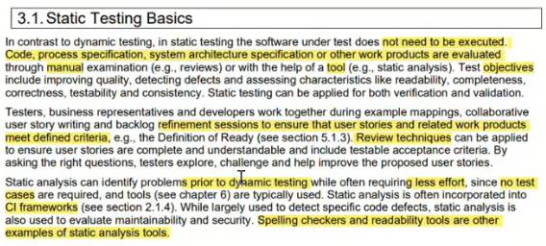

1.1-Work Products Examinable by Static Testing
Chapter 3 - start at 8:31
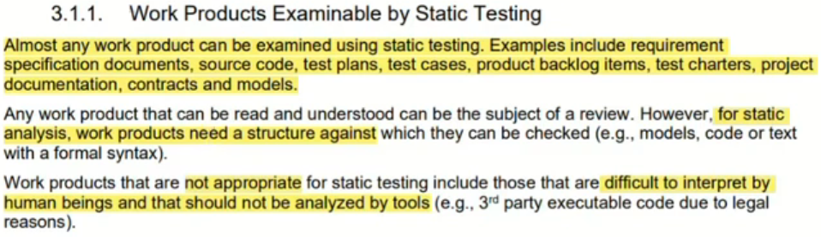

1.2-Value of Static Testing
Chapter 3 - start at 11:40
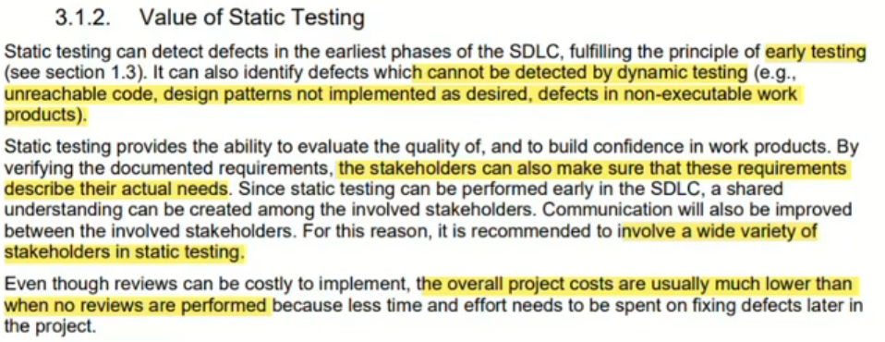

1.3-Differences between Static Testing and Dynamic Testing
Chapter 3 - start at 15:40
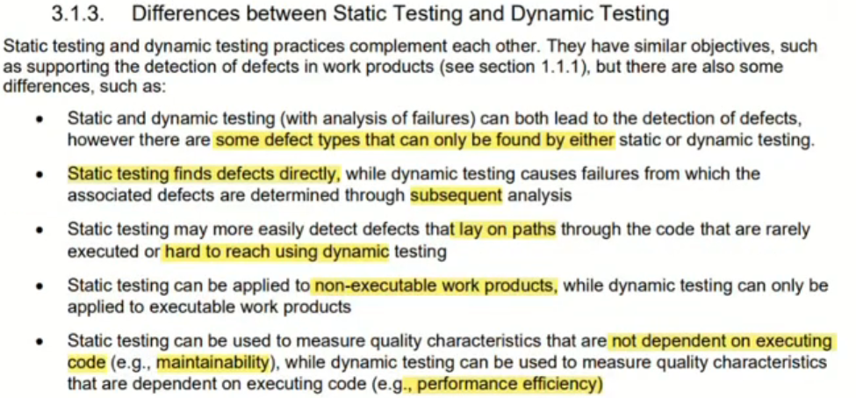
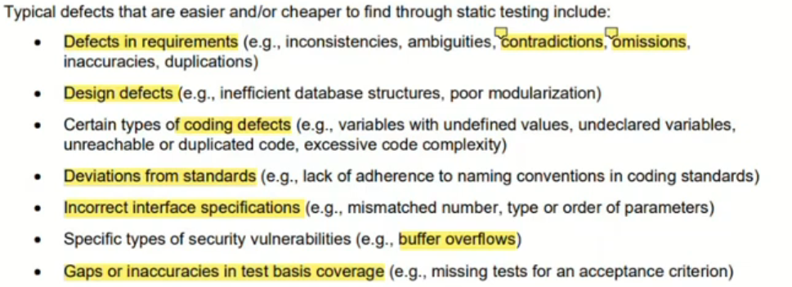

2. Feedback and Review Process
Chapter 3 - start at 25:57

2.1-Benefits of Early and Frequent Stakeholder Feedback
Chapter 3 - start at 25:57
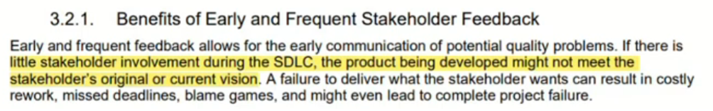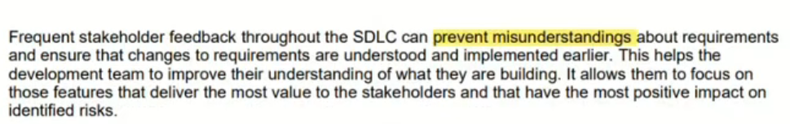

2.2-Review Process Activities
Chapter 3 - start at 27:39
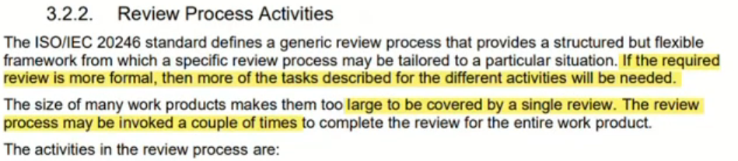
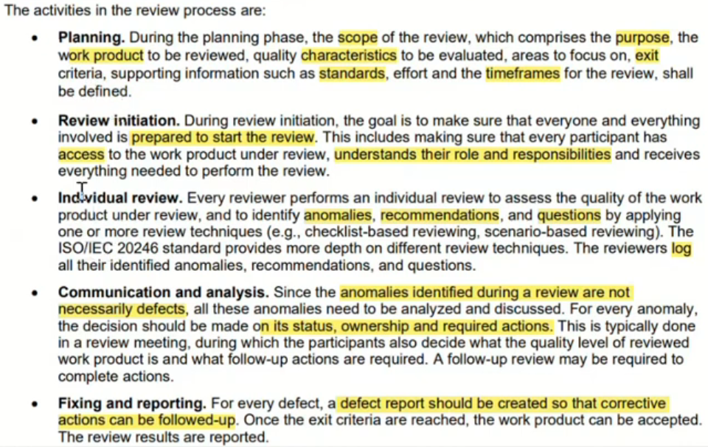

2.3-Roles and Responsibilities in Reviews
Chapter 3 - start at 32:46
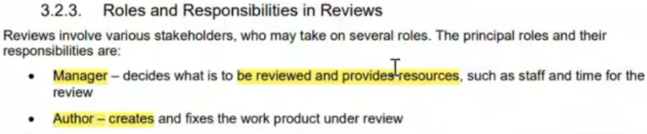
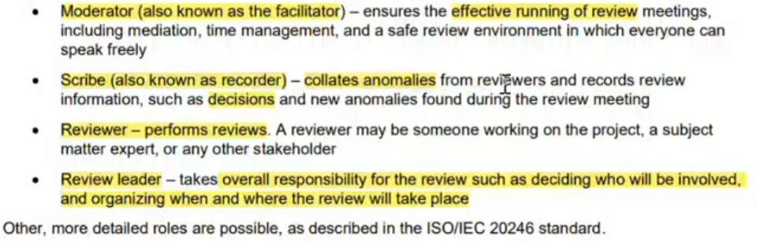

2.4-Review Types
Chapter 3 - start at 35:35
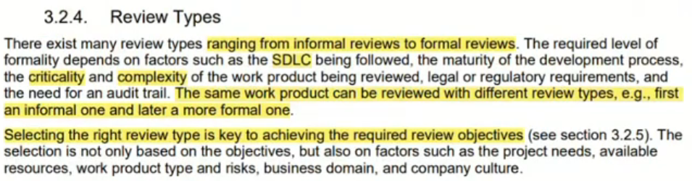
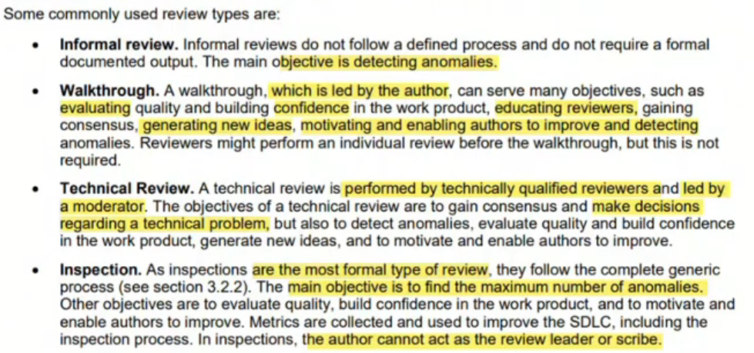

2.5-Success Factors for Reviews
Chapter 3 - start at 41:12
